# Online Writing Portfolios in OneDrive

This year Hamilton students will create their writing portfolios online. We are excited about the opportunity to "go green" and give students access to their writing wherever they are (including on their smartphones).

Students can set up their portfolios in 4 easy steps.

## Step 1: Access Your CUSD OneDrive

1. 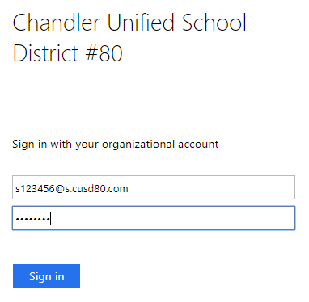Visit [cusd80.com/office365](http://cusd80.com/office365) and click on the Log On button.
2. Log on as follows:
   1. **Username**: [s+studentid@s.cusd80.com](mailto:s+studentid@s.cusd80.com)
   2. **Password**: the same one you use to log on to the computer, access Infinite Campus, etc.
3. Find the  app and click on it.

## Step 2: Create Your Writing Portfolio Folder

1. In OneDrive, click the **New** button to create your folder.
2. Name your folder **LastName, FirstName - Writing Portfolio**, using your own name where appropriate. Example: John Smith would name their writing portfolio  
   **Smith, John - Writing Portfolio**.

## Step 3: Share Your Folder with Your English Teacher

1. 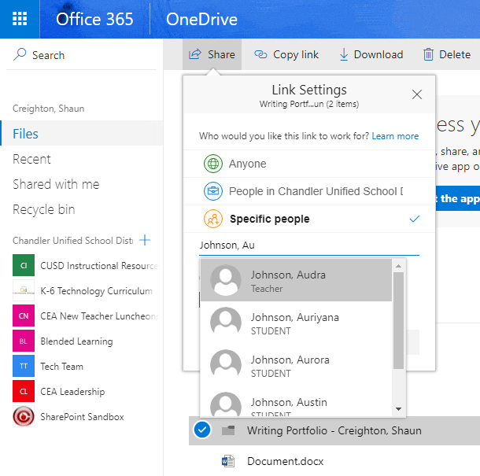Select your folder by checking the checkbox to the left of it and click the **Share** button.
2. Click on **Only you can access this item**.
3. Enter the **last name** of your English teacher to locate them in the sharing list (if your teacher doesn't appear toward the top of the list, you can type a comma and a space, and then start typing their first name to filter the list further).
4. Click on your teacher's name (make sure it says "Teacher" underneath their name).
5. Click **Apply**, then **Send**.

## Step 4: Getting the Folder Link

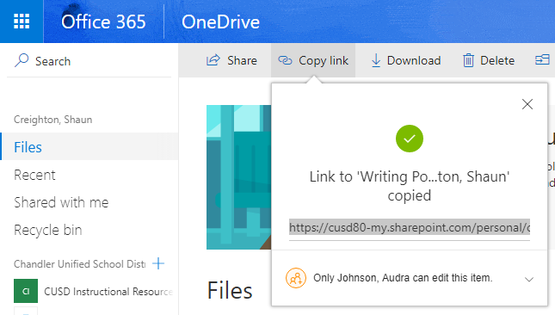Your teacher may wish you to share the link to your portfolio folder. To get this link:

1. Select your folder by checking the checkbox to the left of it and click the **Copy Link** button.
2. Verify the sharing settings are correct (you should see your teacher listed).
3. Click on the link to select it.
4. If you don't get a message saying that the link was copied, right-click on the link and select Copy.
5. Share the link with your teacher following their instructions.